ENSE 805 Project report-out & lessons learned

Disclaimer: This template should be used to guide your discussion. The course facilitator asks that you be as open, honest, and professional in your responses as possible. Please know it is OK to agree/disagree with any concept, process, or idea discussed in this course. The knowledge gained from your open, honest, educated, and professional responses may be discussed at a future Engineering Faculty and/or “Canadian Engineering Education Association (CEEA)” event.

Project name: Eco-Resilient Networks: Smart Deployment for the Future
Team Members: Muhammad Hamza Shahab, Syed Haider Abbas Naqvi

Project sponsor & course facilitator
Dr. Tim Maciag (ENSE 805 professor)

Business need/opportunity
Background
The rapid growth of network services, driven by trends like 5G/6G, IoT, and edge computing, is placing increasing demands on network infrastructure. Telecommunications providers like SaskTel must ensure high availability and low latency for these services while also addressing growing concerns about energy consumption and environmental sustainability. Traditional approaches to network design often prioritize either availability or sustainability, leading to trade-offs and inefficiencies. There's a critical need for new methods that can jointly optimize for both, ensuring
reliable service delivery while minimizing the environmental impact. This project addresses this need by developing and evaluating novel algorithms for virtual networks allocation and embedding in edge-cloud environments.

Business Opportunity
SaskTel, as the leading telecommunications provider in Saskatchewan, needs to continuously improve the availability, performance, and sustainability of its network infrastructure to meet the evolving needs of its customers and fulfill its commitment to corporate social responsibility.
Specifically, there's a need to:
- Enhance Network Availability: Minimize service downtime and ensure reliable connectivity, even in the face of node or link failures. This is crucial for supporting critical applications and services, particularly in rural areas.
- Reduce Environmental Impact: Decrease the energy consumption and carbon footprint of their network operations, contributing to provincial and national sustainability goals.
- Optimize Resource Utilization: Improve the efficiency of resource allocation (CPU, memory, bandwidth) in edge and cloud environments, reducing operational costs and maximizing the utilization of existing infrastructure.
- Prepare for the Future: Future proof the network, preparing it for 6G and beyond.
This project provides an opportunity for SaskTel to proactively address these needs by exploring and potentially adopting innovative solutions for SFC management that can deliver both high availability and improved sustainability. It also offers an opportunity to enhance their reputation as a technology leader and a responsible corporate citizen.

Reflections on project planning
UN SDGs & Project Alignment
Our project explicitly focused on aligning with the following UN Sustainable Development Goals:
- SDG 7: Affordable and Clean Energy: Directly addressed by developing algorithms to minimize energy consumption and carbon footprint in network operations. The "Carbon-Aware" and "Tradeoff-Aware" embedding policies were designed with this goal central to their function.
- SDG 11: Sustainable Cities and Communities: Supported by enhancing the reliability and efficiency of network infrastructure, which is foundational for smart city services and ensuring equitable access to digital resources.
- SDG 12: Responsible Consumption and Production: Promoted by optimizing the use of network resources (compute, bandwidth), minimizing waste, and encouraging more sustainable patterns of digital infrastructure operation.
- SDG 13: Climate Action: Directly contributed by developing methods to reduce the carbon emissions associated with network operations, a significant and growing contributor to global energy consumption.

Why these SDGs?
The selection stemmed from recognizing the undeniable environmental impact of the rapidly growing ICT sector. The increasing reliance on data centers, cloud services, and ubiquitous connectivity comes with a substantial energy cost. We felt a responsibility as future engineers to address this challenge proactively. The "why" of our project was grounded in the belief that technological progress (like 5G) and environmental stewardship must be pursued concurrently, not as opposing forces. The SDGs provided a globally recognized framework to articulate and validate this purpose. The initial understanding was broad, but the project planning process helped us connect specific technical goals (like reducing simulated energy consumption) directly to these global targets.

Community Research & Requirements
- Key Findings: Our community research focused on SaskTel network engineers and architects as the primary stakeholders (P01, P04). We identified them as being in a "Stable and adapting" lifecycle stage, meaning they have established infrastructure but need tools to optimize and adapt to new demands (5G, sustainability). Their key needs revolved around solutions that integrate with existing systems, minimize operational disruption, and offer clear, demonstrable benefits (P01, P05). The Technology Inventory (P02) revealed a complex ecosystem of NMS, SDN, Cloud, and NFV platforms, but highlighted a significant gap: the lack of tools explicitly designed for joint availability and sustainability optimization. Important operational KPIs beyond availability and carbon footprint included latency, packet loss, jitter, throughput, and resource utilization (P05 - Scratchpad).
- Professional Opinion on Planning Process: The documentation process (P01-P08) was generally very helpful, though demanding. The Community Characteristics (P01) and Technology Inventory (P02) documents forced a deep dive into understanding the target user and their context, which was invaluable for grounding the project in reality, even within a simulation environment. Identifying the dominant community orientations (Projects, Content, Access to Expertise, Service Context) ensured our proposed solution would resonate with their core activities (P01). The Stakeholder Analysis (P04) helped clarify roles and potential influences. The Business Case (P03) framed the project's value, while the Scope (P06) and Requirements (P07) provided essential boundaries and specifications. The Activity-Based Schedule (P08) kept us on track. While some documents felt lengthy at the time (as noted in P09-final), their structured approach ensured all critical planning aspects were considered, preventing potential issues later. A potential improvement might be slightly more condensed templates or clearer guidelines on the required level of detail for each section in an academic context.

Customers & Golden Circle
- North Star Customers: SaskTel network engineers and architects. They are the direct users who would leverage the simulation framework and algorithms to make informed deployment decisions.
- Carryover Customers: Saskatchewan businesses and residents (benefiting from improved network reliability and potentially lower costs passed on) and the broader research community (benefiting from the findings and open-source framework).
- Importance (Golden Circle):
  - Why: These customers represent the core purpose – to improve network operations for a real-world provider, benefiting the broader community it serves while advancing sustainable practices.
  - How: The project provides simulation tools and optimization algorithms specifically designed to balance the critical needs (availability, sustainability) identified through community analysis.
  - What: The project delivers a functional simulation framework, validated algorithms, performance analysis, and actionable insights (via documentation and the research paper).

Assumptions & Constraints
- Key Assumptions: We assumed fixed network topologies and SFCs for the initial MVPs, independent node/link failures, and that the simulation would run locally. We also assumed a single, representative SFC type for initial testing (P06 - Exclusions). The carbon footprint modeling was based on available benchmarks, not detailed, real-time energy pricing or specific hardware costs.
- Constraints: The primary constraints were the academic timeline, the focus on simulation rather than live deployment, and the lack of direct access to SaskTel's internal network data or systems.
- Drafting an Emerging Picture (P05): This document was crucial for synthesizing the community analysis and technology inventory. It helped solidify the understanding that the key gap was the lack of tools for joint optimization and the lack of integration between operational performance and sustainability metrics. This directly informed the project's core objective and the design of the embedding policies (especially TAE). It also guided the refinement of the MVPs towards a more focused and achievable scope.

Technology Stack Evolution
- Initial Stack: Python + CloudSim. Python was chosen for its extensive libraries for data analysis, networking (NetworkX), and optimization (DEAP). CloudSim was initially considered for its detailed simulation capabilities.
- Evolution: We added NetworkX early on for robust topology modeling. NumPy and Pandas became essential for data manipulation and analysis. Matplotlib was added for visualization. We shifted focus towards a more custom simulation core built on Python fundamentals, integrating Mininet for simpler network emulation if needed for specific MVP stages, moving away from full reliance on CloudSim due to complexity and the specific focus required. DEAP was confirmed for GA implementation.
- MVP Evolution: The initial MVP concept was broader. Informed by the "Emerging Picture" and the need for a manageable scope within the timeline, we focused the application on 5G video streaming optimization (P05 - MVP notes).
  - MVP 1 focused on establishing the core simulation environment, basic topology/SFC modeling, data I/O, and visualization (P06).
  - MVP 2 focused on implementing the core embedding policies (AAE, CAE, TAE) and the primary optimization algorithm (PSO), along with performance metric calculations (P06, P07).
  - MVP 3 focused on documentation (User Guide, Research Paper, Code Docs) and implementing additional algorithms (SA, GA) if time permitted (P06).
  - MVP 4 (Delivery) focused on integrating all components, testing, and preparing final deliverables (Video, Presentation) (P06). This evolution ensured a phased approach, delivering functional components incrementally.
- The GitHub repo structure and the tech dependencies utilized in the project are illustrated in Figure 1 and Figure 2 respectively.
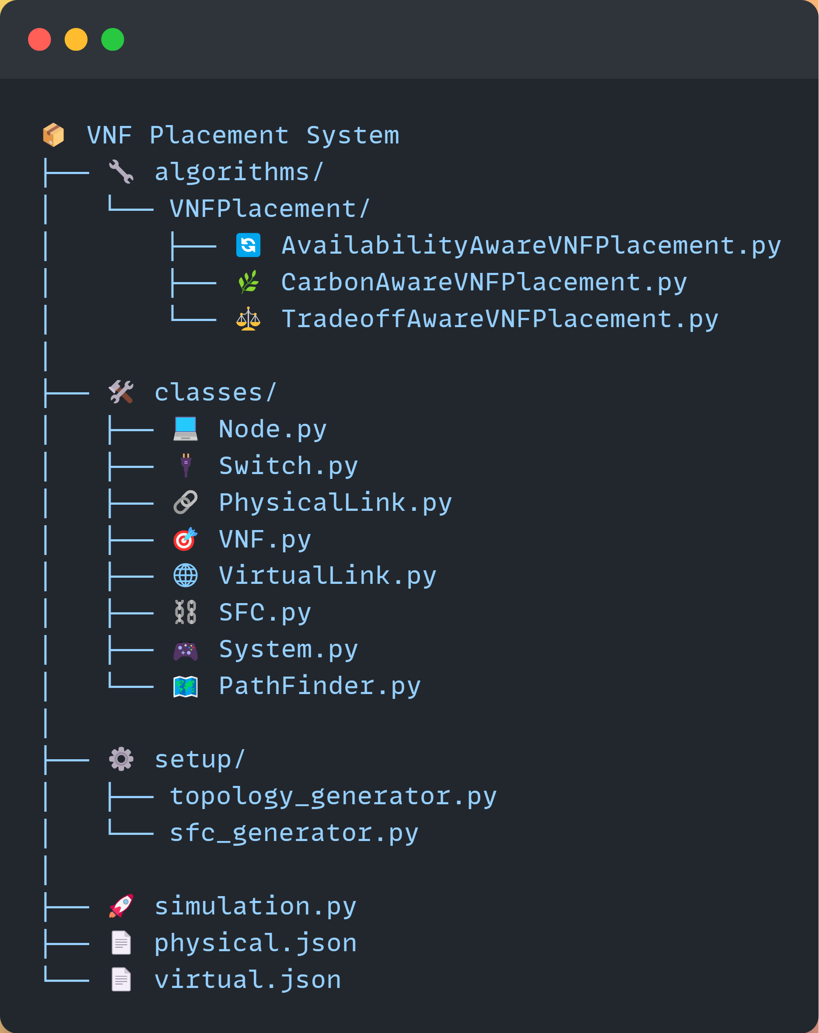
Figure 1 File structure
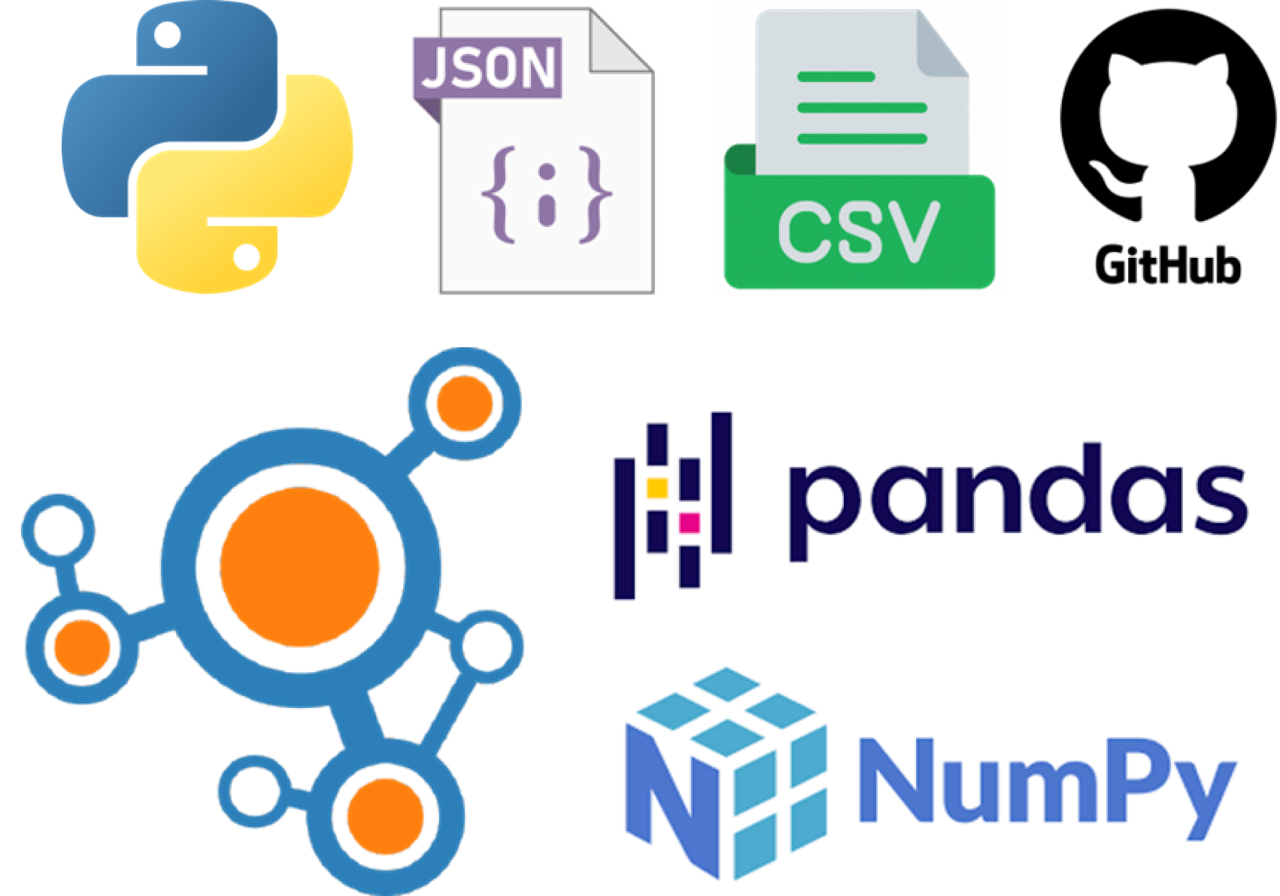
Figure 2 Technology Stack

Reflections on project results
Project Deliverables
The project successfully delivered a functional simulation framework designed to optimize SFC deployment in edge-cloud environments, specifically targeting the balance between availability and sustainability for 5G video streaming. Key features and deliverables include:
- Network Simulation: A Python-based framework capable of simulating fat-tree and potentially custom network topologies, including nodes (with resource capacities and energy profiles), links (with bandwidth and latency), and switches.
- SFC Definition: Functionality to define SFCs comprising various VNFs (e.g., firewall, load balancer, video transcoder, packet gateway) with specified resource requirements (CPU, memory) and availability targets.
- Embedding Policies: Implementation and integration of three distinct policies:
  - Availability-Aware Embedding (AAE): Prioritizes placing VNFs on nodes/paths to maximize overall SFC availability.
  - Carbon-Aware Embedding (CAE): Prioritizes placing VNFs on energy-efficient nodes to minimize the carbon footprint.
  - Tradeoff-Aware Embedding (TAE): Provides a flexible approach using a weighting factor (α) to balance availability and carbon footprint objectives.
- Optimization Algorithms: Implementation and integration of metaheuristic algorithms for VNF redundancy and placement optimization:
  - Particle Swarm Optimization (PSO): An optimization algorithm inspired by swarm behavior, where particles refine redundancy levels by balancing exploration and local optimization.
  - Simulated Annealing (SA): A probabilistic optimization method that adjusts redundancy configurations iteratively, avoiding local optima using a temperature-guided acceptance mechanism.
  - Genetic Algorithm (GA): An evolutionary algorithm that evolves redundancy configurations through selection, crossover, and mutation to optimize availability and resource usage.
- All the embedding policies and optimization algorithms are part of the Eco-Resilient framework as presented in Figure 3.
- Performance Metrics: Calculation modules for key metrics: Availability (%), Carbon Footprint (kgCO2 estimated based on energy models), Latency (ms), number of redundant instances and Algorithm Execution Time (s). These were validated against defined SLA constraints (P07). The results of these metrics are presented in Figure 4.
- Data I/O: Modules for reading network and SFC configurations from JSON files and exporting simulation results to CSV format.
- Visualization: Basic visualization capabilities using Matplotlib to display network topology, VNF placement, and key performance trade-off graphs.
- Documentation: Comprehensive documentation including:
  - A detailed User Guide covering installation, configuration, running simulations, and interpreting results.
  - A finalized Research Paper detailing the project's methodology, results, analysis, discussion, and conclusions.
  - Thorough code documentation (docstrings, comments).
- Delivery Components: A standalone Python application integrating all components, a 1-2 minute non-technical video commercial, and a 15-minute technical presentation.
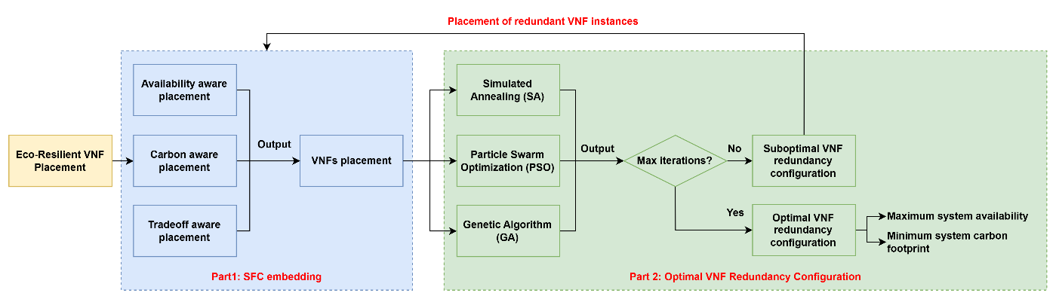
Figure 3 Eco-resilient framework
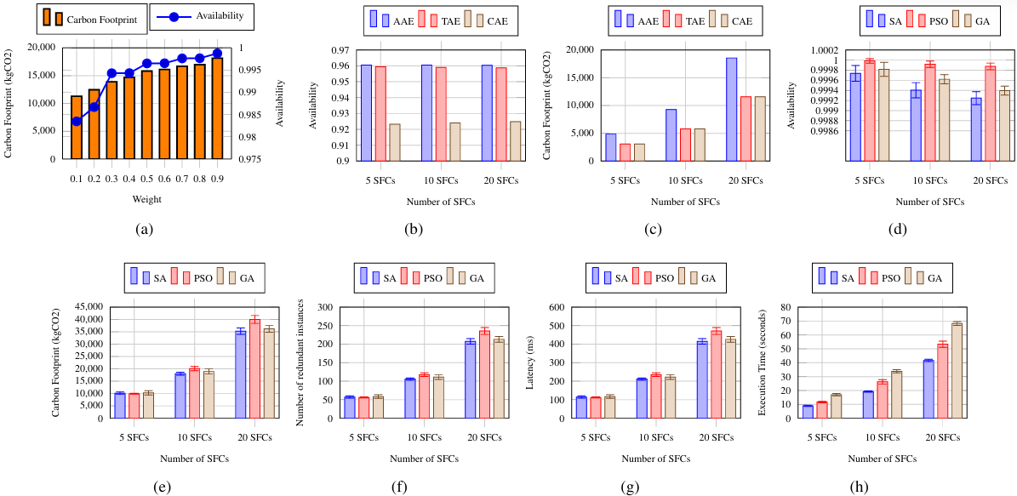
Figure 4 Results
Comparison with Initial Vision
The final solution aligns very closely with the initial vision outlined in the project pitch and planning documents. The core goal of developing a simulation framework to jointly optimize for availability and sustainability was achieved. The key functionalities, including the embedding policies and optimization algorithms, were implemented as planned. The refinement to focus specifically on 5G video streaming provided a concrete application domain without deviating from the fundamental objectives. While the initial thought might have been a broader tool, focusing the application made the results more tangible and the development more manageable within the academic timeframe. The envisioned deliverables (simulation, algorithms, paper, documentation) were all successfully produced.

Software Design & Lecture Links
Our software design process was consciously informed by concepts discussed in ENSE 805:
- Community-Centered Design (CoPs/Digital Habitats): We explicitly designed the tool with the SaskTel network engineer community in mind. Understanding their "Stable and adapting" state and dominant orientations (Projects, Content, Expertise, Service Context) guided our focus on creating a simulation tool (supporting Projects and Expertise) that generates actionable data (Content) relevant to their service context. We addressed their "reification" orientation by focusing on optimizing the network itself.
- Technology Stewardship: We aimed to be responsible technology stewards by creating a tool that not only solves a technical problem but also addresses a critical societal need (sustainability) aligned with UN SDGs.
- Knowledge Management & CC: The project embodies the data-to-information-to-knowledge pipeline. The simulation framework acts as a tool for knowledge creation. By planning to make the framework open-source, we Creative Commons (CC) model, allowing others to build upon and share knowledge.
- Agile/Iterative Development (PDSA): The use of MVPs and sprint cycles mirrored the Plan-Do-Study-Act cycle. Each sprint involved planning (selecting work packages), doing (implementation), studying (testing, demoing, getting feedback in scrums), and acting (refining code, adjusting plans for the next sprint).
- Object-Oriented Principles & Design Patterns: Python's OOP nature was leveraged to create modular and maintainable code (e.g., classes for Network Components, Algorithms, Policies). While not explicitly complex patterns, the structure followed principles of modularity and encapsulation.
- Version Control: Git/GitHub was used rigorously for version control, collaboration, and maintaining code history.

Project Experience
Overall, the project was a valuable learning experience.
- Likes: The opportunity to tackle a relevant, real-world problem with a significant sustainability component was highly motivating. The hands-on experience with simulation, optimization algorithms (PSO, SA, GA), and network modeling was valuable. Successfully implementing and demonstrating the tradeoff between availability and sustainability was particularly rewarding. Contributing potentially publishable research was a great outcome.
- Dislikes: Integrating different Python libraries sometimes presented minor compatibility challenges. The process of thoroughly documenting the code and writing the user guide and research paper was time-consuming, although necessary. Achieving optimal performance with the metaheuristic algorithms required significant tuning and experimentation.
- What Went Well: Project goals were clear from the outset. Collaboration and communication within the team were effective. The core simulation framework was implemented successfully and proved robust. The iterative MVP approach allowed for steady progress and early feedback. The final deliverables aligned well with the project plan.
- What Didn't Go Well (Minor): Initial setup of the specific simulation environment (choosing between CloudSim/Mininet/Custom) took slightly longer than anticipated. Some optimization algorithms (potentially SA or GA) might have benefited from more development time if the schedule wasn't as tight. Documentation, while completed, sometimes felt like a bottleneck.
- Do Same on Future Projects: Maintain a structured project management approach (clear scope, requirements, schedule). Prioritize clear and frequent communication. Focus on delivering functional MVPs incrementally. Use version control consistently. Emphasize community/user needs early in the planning.
- Do Differently on Future Projects: Allocate more buffer time for initial environment setup and complex algorithm tuning. Explore more automated documentation tools or techniques earlier. Investigate a wider range of visualization libraries from the start to find the most effective ones for specific data types. Seek industry feedback even earlier in the process, if possible.

Future Work
The current simulation framework provides a strong foundation for future research and development:
- Real-World Data Integration: The most impactful next step would be to integrate the framework with anonymized, real-world network data (topology, traffic patterns, VNF profiles, energy consumption) from SaskTel or another operator. This would significantly enhance the realism and validation of the results.
- Graphical User Interface (GUI): Developing a user-friendly GUI would make the simulation framework more accessible to network engineers who may not be comfortable with command-line interfaces and JSON configuration.
- Expanded Algorithms/Policies: Explore more sophisticated optimization algorithms (e.g., reinforcement learning, hybrid approaches) and more nuanced embedding policies (e.g., policies that consider latency variations, security constraints, or dynamic resource pricing).
- Dynamic Network Conditions: Extend the framework to simulate dynamic conditions, such as fluctuating traffic loads, VNF scaling events, and node/link failures (including correlated failures), and evaluate how the algorithms adapt.
- Broader Scenarios: Apply the framework to other network scenarios beyond 5G video streaming, such as IoT deployments, mission-critical communications, or general enterprise networking in 6G contexts.
- SDN/Orchestrator Integration: Investigate the feasibility of integrating the optimization engine with real-world SDN controllers or NFV orchestrators via APIs, enabling automated deployment based on the simulation results.
- Deepen Carbon Modelling: Collaborate with sustainability researchers to incorporate more detailed and accurate carbon footprint models, potentially including factors like electricity grid mix variations (PUE - Power Usage Effectiveness) and embodied carbon of hardware.

General reflections on the class & project experience
Before taking ENSE 805, were you aware of the UN SDGs?
Yes - Before taking ENSE 805, my awareness of the UN SDGs was general. I knew they existed as a set of global goals promoted by the UN, covering areas like poverty, health, and the environment. However, my understanding was superficial. I didn't grasp the specific targets within each goal, nor had I deeply considered their direct relevance to the field of software and systems engineering. They seemed like high-level policy objectives rather than actionable principles for technical design.

Typically, before taking this class, when you engineered software solutions, were you concerned with areas encompassing the UN SDGs?
Typically, no. In previous academic projects or hypothetical software engineering scenarios I'd encountered, the primary concerns were almost always functional requirements, performance (speed, efficiency), usability, and sometimes security or cost. Areas directly related to broader societal or environmental impacts, as framed by the SDGs, were rarely, if ever, explicit design considerations. For example, when designing a data processing application, the focus would be on processing speed and accuracy, not necessarily on the energy footprint of the servers running the application or the ethical implications of the data being processed (unless it was a security/privacy requirement). The potential for a software solution to contribute positively or negatively to goals like "Responsible Consumption" or "Climate Action" wasn't a standard part of the engineering mindset I had been exposed to.

Did learning about the UN SDG(s) help you understand better your role and responsibility as an engineer to society?
Yes - Learning about the UN SDGs in the context of ENSE 805 significantly broadened my perspective on the role and responsibility of an engineer in society. It moved beyond the traditional view of simply solving technical problems to encompass a more holistic understanding of how engineering solutions impact the world. I now see engineers not just as builders, but as agents who can actively shape a more sustainable and equitable future. The lectures and project work highlighted that design choices, even seemingly small technical ones (like algorithm selection or resource allocation), can have tangible consequences for energy consumption, resource depletion, and community well-being. This instilled a greater sense of responsibility to consider these broader impacts throughout the engineering lifecycle. It underscored the idea that engineering ethics extends beyond immediate safety and functionality to include long-term societal and environmental consequences.

What was your experience(s) in engineering your specific software solution to address the UN SDG(s) selected?
Engineering the "Eco-Resilient Networks" project with specific SDGs in mind was both challenging and deeply rewarding.
- Challenge: It added complexity. We couldn't just optimize for availability; we had to constantly consider the conflicting objective of minimizing the carbon footprint. This required developing new metrics (like the carbon footprint estimation), implementing more complex optimization strategies (like the Tradeoff-Aware policy and multi-objective considerations in PSO/SA/GA), and analyzing results through a multi-dimensional lens. It forced us to think about trade-offs explicitly and make design decisions that balanced competing goals.
- Reward: It provided a profound sense of purpose. Knowing that the technical work could contribute, even in a simulated way, to significant goals like climate action and sustainable infrastructure was highly motivating. It made the project feel more meaningful than simply fulfilling technical requirements. It connected the theoretical concepts of algorithms and simulation to tangible global challenges.
As a future engineer, what are your thoughts on the UN SDGs as a whole? Do you think they can help or hinder our work as software engineers?
I believe the UN SDGs primarily help our work as software engineers, although they introduce complexity.
- Help: They provide a valuable ethical framework and a set of common goals that can guide design decisions, especially when faced with ambiguous requirements or conflicting priorities. They encourage innovation by pushing us to find solutions that are not just functional but also responsible. They can help align technical projects with broader organizational or societal values (like corporate social responsibility). They provide a common language for discussing the societal impact of our work.
- Hinder (Potential): They can add complexity to the design process, requiring consideration of more factors and potentially conflicting objectives. In some cases, prioritizing an SDG might conflict with a client's immediate, short-term goals (e.g., minimizing upfront cost even if it leads to higher long-term energy use). Navigating these conflicts requires careful communication and a focus on finding balanced solutions. However, I see this "hindrance" more as a necessary challenge inherent in responsible engineering rather than a fundamental flaw in using the SDGs.
Should we use the UN SDGs to guide our work or is our work dependent on customer requests, regardless of the UN SDGs?
This presents a complex ethical and practical dilemma for engineers. Ideally, our work should be guided by frameworks like the UN SDGs, reflecting our broader professional responsibility to society and the environment. However, in many professional contexts, our work is directly driven by customer requirements and project funding. I believe the answer lies not in an either/or approach, but in integration and advocacy.
We should absolutely use the UN SDGs to guide our work. They provide a critical lens through which to evaluate project goals, design choices, and potential impacts. As engineers, we should proactively look for opportunities to align our solutions with relevant SDGs, even if not explicitly requested by the customer.
Simultaneously, we must acknowledge that customer requests are often the primary driver. Where customer requests directly conflict with SDG principles (e.g., a request for a highly inefficient but cheap solution), our responsibility includes:
- Communicating the Trade-offs: Clearly explaining the potential negative impacts (environmental, social, long-term economic) of ignoring SDG considerations.
- Advocating for Better Solutions: Proposing alternative solutions that meet the customer's core functional needs while also aligning better with SDG principles. This might involve demonstrating long-term cost savings from energy efficiency or highlighting the positive reputational benefits of sustainability.
- Seeking Balance: Striving to find innovative solutions that satisfy both customer requirements and contribute positively (or at least minimize negative impacts) towards relevant SDGs.
Ultimately, while customer satisfaction is essential, our professional ethics should compel us to advocate for responsible engineering practices informed by frameworks like the UN SDGs. This course has reinforced the idea that our role extends beyond purely technical execution to include considering the broader context and consequences of our work. We should aim to educate clients and stakeholders on the importance and long-term value of sustainable and ethical considerations, making the SDGs an integral part of the conversation, not an afterthought or something ignored when not explicitly demanded.

Will you use your understanding of the UN SDGs in engineering solutions in the future?
Yes, absolutely. I will definitely use my understanding of the UN SDGs in future engineering solutions. It has become an integral part of how I view the engineering process. My approach would be:
- Proactive Consideration: Integrate SDG considerations early in the requirements gathering and design phases, not as an afterthought.
- Identify Relevant Goals: Determine which SDGs are most relevant to the specific project and its context.
- Define Metrics: Establish metrics to measure the project’s impact (positive or negative) on the chosen SDGs.
- Balanced Optimization: Strive to find solutions that optimize for traditional engineering goals (performance, cost) while also advancing relevant SDGs. This involves acknowledging trade-offs and making informed decisions.
- Communication: Clearly communicate the SDG alignment and impact to stakeholders, including clients, to justify design choices and build support for sustainable solutions. Even when customer requests seem purely technical, I will look for opportunities to introduce or highlight SDG-aligned benefits.
Will your experience learning about the UN SDGs inform your career path decisions in the future?
Yes, this experience will likely inform my career path decisions. I am now significantly more interested in working on projects or for organizations where sustainability and social responsibility are core values. The experience of engineering a solution directly aimed at reducing environmental impact was fulfilling. I would be more inclined to seek roles in areas like green computing, sustainable infrastructure development, technology for social good, or companies with strong, demonstrable commitments to the UN SDGs. It has added a new layer of criteria beyond purely technical interest when evaluating future opportunities.

Provide any other comments on the project
This project was an excellent practical application of the theoretical concepts covered in ENSE 805. The focus on community-centered design, even when the "community" was modeled based on a real-world organization like SaskTel, provided valuable context. The structured approach using the various planning documents (P01-P08) ensured a comprehensive understanding before diving deep into implementation. The iterative nature of the MVPs and scrum check-ins was beneficial for maintaining momentum and incorporating feedback. The emphasis on sustainability and the UN SDGs made the project particularly meaningful and relevant to contemporary engineering challenges. It was a challenging but ultimately very rewarding experience that has significantly shaped my perspective on the role of engineering in society.

